Interbank Networks
# Source: AI Source: Provided by: [Data Path: Persons Table -> ID Column: 1, Name_En Column: Motasem Essam] -> From: [ChatGPT] on [1/21/2026]
Interbank Networks are financial infrastructures that allow money to be transferred between different banks. They form the core of the settlement process when the sender and receiver of funds are in different banks or financial institutions — especially in bank transfers, direct debits, and ACH payments.

🧠 Simple Definition
# Source: AI Source: Provided by: [Data Path: Persons Table -> ID Column: 1, Name_En Column: Motasem Essam] -> From: [ChatGPT] on [1/21/2026]
An interbank network is a system that facilitates the movement of funds between banks, enabling settlements across accounts at different financial institutions.

🔄 When Interbank Networks Are Used
# Source: AI Source: Provided by: [Data Path: Persons Table -> ID Column: 1, Name_En Column: Motasem Essam] -> From: [ChatGPT] on [1/21/2026]
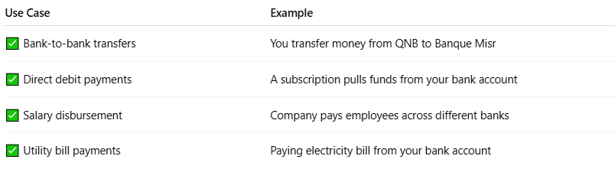

Use Case | Example
✅ Bank-to-bank transfers | You transfer money from QNB to Banque Misr
✅ Direct debit payments | A subscription pulls funds from your bank account
✅ Salary disbursement | Company pays employees across different banks
✅ Utility bill payments | Paying electricity bill from your bank account

⚙️ How Interbank Settlement Works (Simplified)
# Source: AI Source: Provided by: [Data Path: Persons Table -> ID Column: 1, Name_En Column: Motasem Essam] -> From: [ChatGPT] on [1/21/2026]
- You initiate a bank transfer (online, mobile app, or manually).
- Your bank sends the transaction request to the interbank settlement system.
- The central clearing system matches and validates the transaction.
- Funds are transferred from your bank’s reserve to the recipient’s bank.
- The receiving bank credits the beneficiary’s account.

🏛️ Examples of Interbank Networks
# Source: AI Source: Provided by: [Data Path: Persons Table -> ID Column: 1, Name_En Column: Motasem Essam] -> From: [ChatGPT] on [1/21/2026]
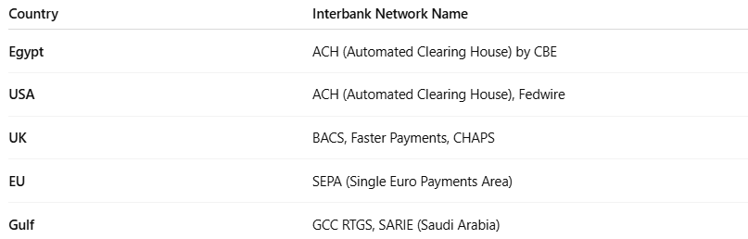

Country | Interbank Network Name
Egypt | ACH (Automated Clearing House) by CBE
USA | ACH (Automated Clearing House), Fedwire
UK | BACS, Faster Payments, CHAPS
EU | SEPA (Single Euro Payments Area)
Gulf | GCC RTGS, SARIE (Saudi Arabia)

🔐 Core Functions
# Source: AI Source: Provided by: [Data Path: Persons Table -> ID Column: 1, Name_En Column: Motasem Essam] -> From: [ChatGPT] on [1/21/2026]
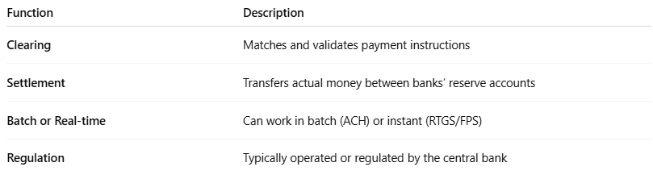

Function | Description
Clearing | Matches and validates payment instructions
Settlement | Transfers actual money between banks’ reserve accounts
Batch or Real-time | Can work in batch (ACH) or instant (RTGS/FPS)
Regulation | Typically operated or regulated by the central bank

📊 Batch vs. Real-Time Interbank Settlement
# Source: AI Source: Provided by: [Data Path: Persons Table -> ID Column: 1, Name_En Column: Motasem Essam] -> From: [ChatGPT] on [1/21/2026]
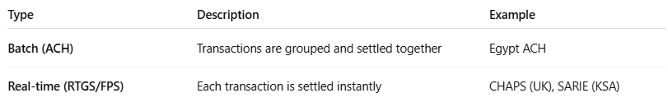

Type | Description | Example
Batch (ACH) | Transactions are grouped and settled together | Egypt ACH
Real-time (RTGS/FPS) | Each transaction is settled instantly | CHAPS (UK), SARIE (KSA)

📦 Why Interbank Networks Matter
# Source: AI Source: Provided by: [Data Path: Persons Table -> ID Column: 1, Name_En Column: Motasem Essam] -> From: [ChatGPT] on [1/21/2026]
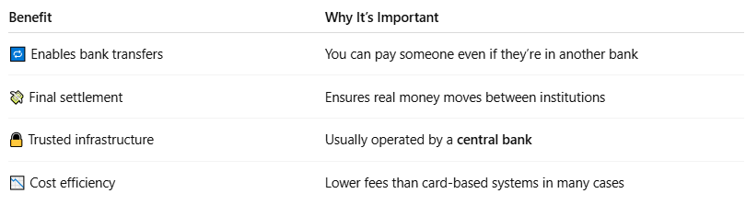

Benefit | Why It’s Important
🔁 Enables bank transfers | You can pay someone even if they’re in another bank
💸 Final settlement | Ensures real money moves between institutions
🔒 Trusted infrastructure | Usually operated by a central bank
📉 Cost efficiency | Lower fees than card-based systems in many cases

🧠 Summary
# Source: AI Source: Provided by: [Data Path: Persons Table -> ID Column: 1, Name_En Column: Motasem Essam] -> From: [ChatGPT] on [1/21/2026]
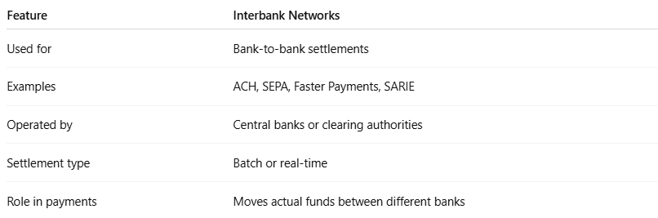

Feature | Interbank Networks
Used for | Bank-to-bank settlements
Examples | ACH, SEPA, Faster Payments, SARIE
Operated by | Central banks or clearing authorities
Settlement type | Batch or real-time
Role in payments | Moves actual funds between different banks

